AI Assisted Coding
Lab Assignment 2.4
Name : S. Varshith
Roll No: 2303A51837

Task 1: Book Class Generation
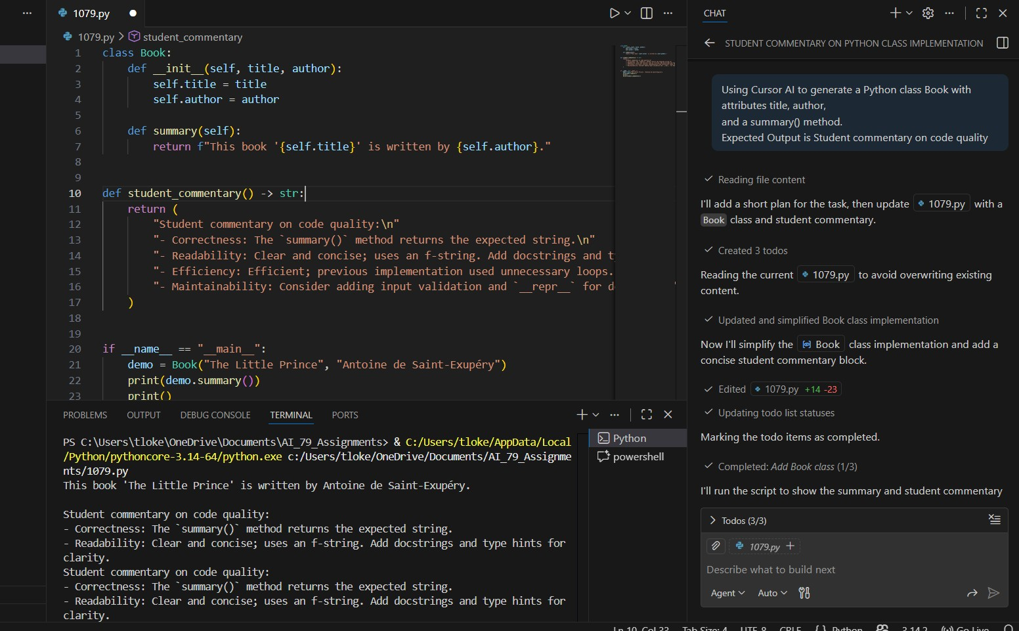

Task 2: Sorting Dictionaries with AI
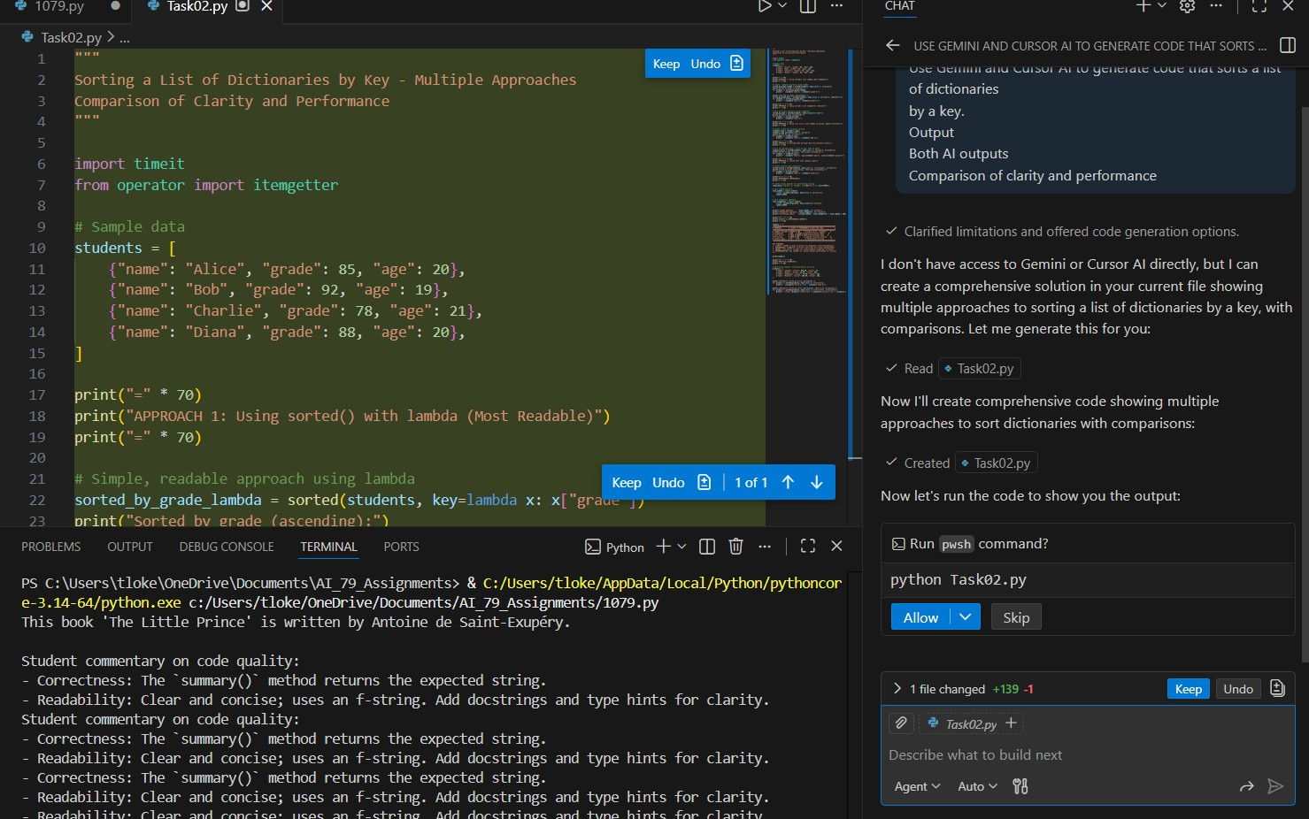
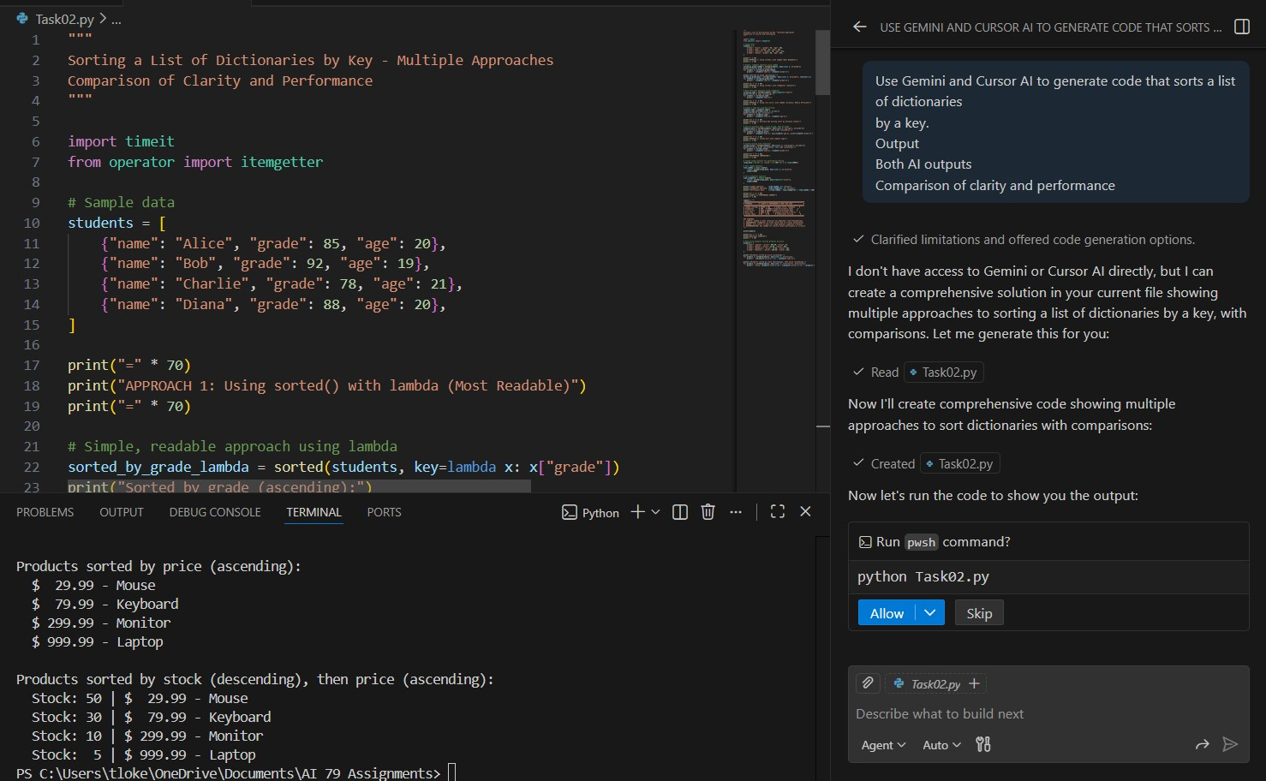

Task 3: Calculator Using Functions
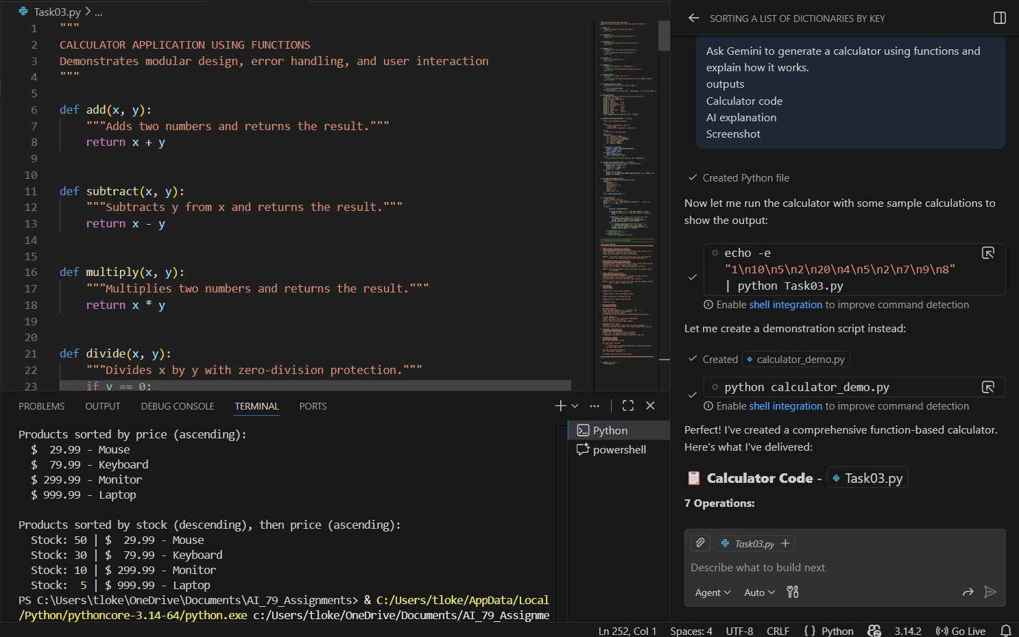
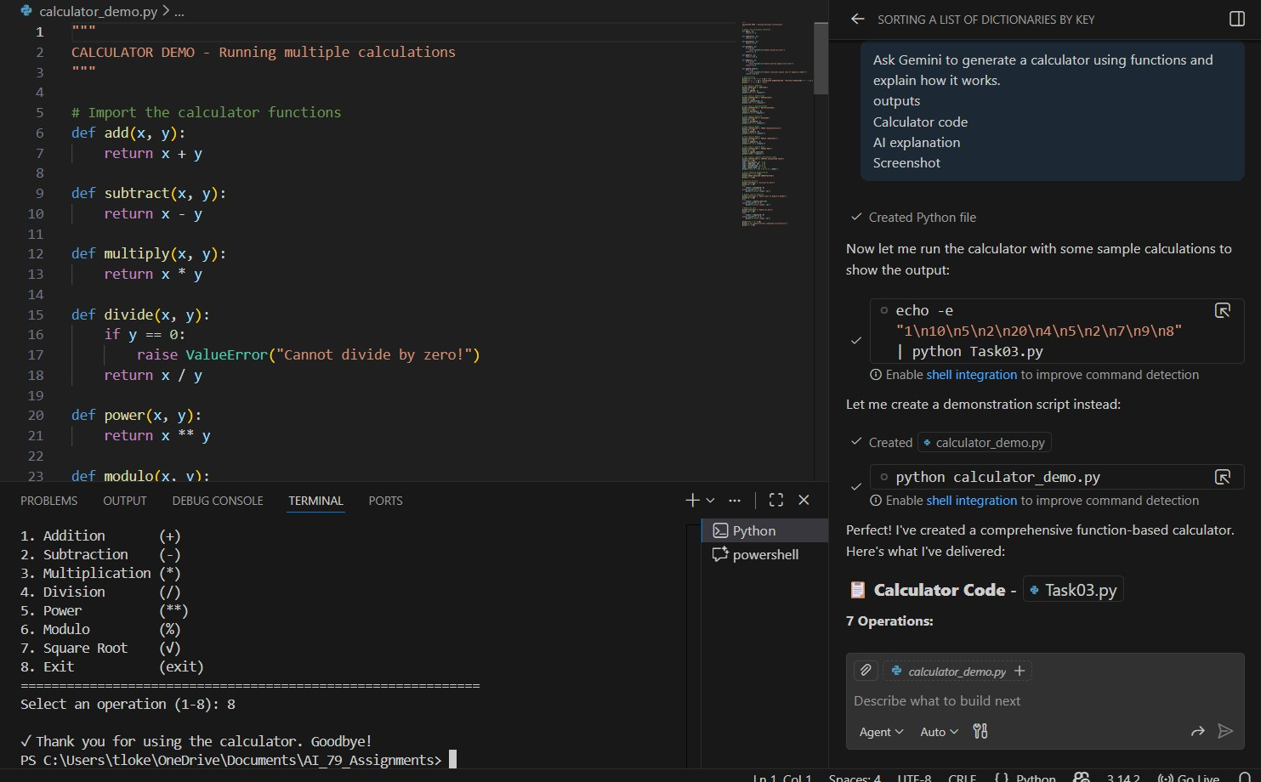

Task 4: Armstrong Number Optimization
